Automated Resume Analysis & Skill Suggesting Website using NLP

In this project using Resume Parser and NLP API we are parsing resume to extract details like skills, qualification and personal details and this extraction is very helpful for companies where they are not supposed to manually scan each and every resume. Once resume uploaded then based on required skills and applicant skills score will be calculated and if score is high then company will shortlist those applicant and call for interviews.

To run project install Python 3.7.0 and then install below packages

Pip install Django==2.1.7

Pip install numpy==1.19.2

Pip install pyresparser==1.0.6

Pip install PyMySQL==0.9.3

Pip install matplotlib==3.1.1

Now double click on ‘run.bat’ file to start python DJANGO server and then open browser and enter URL as <http://127.0.0.1:8000/index.html>’ and press enter key to get below page

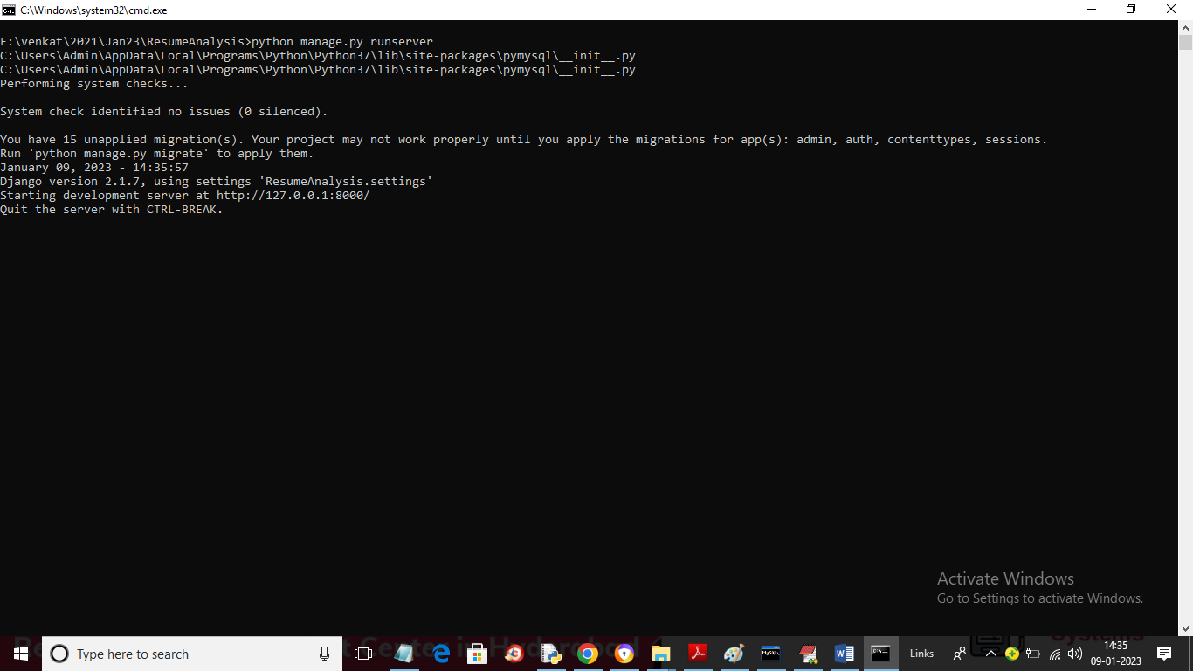

In above screen Django server started and now open browser and enter URL to get below page

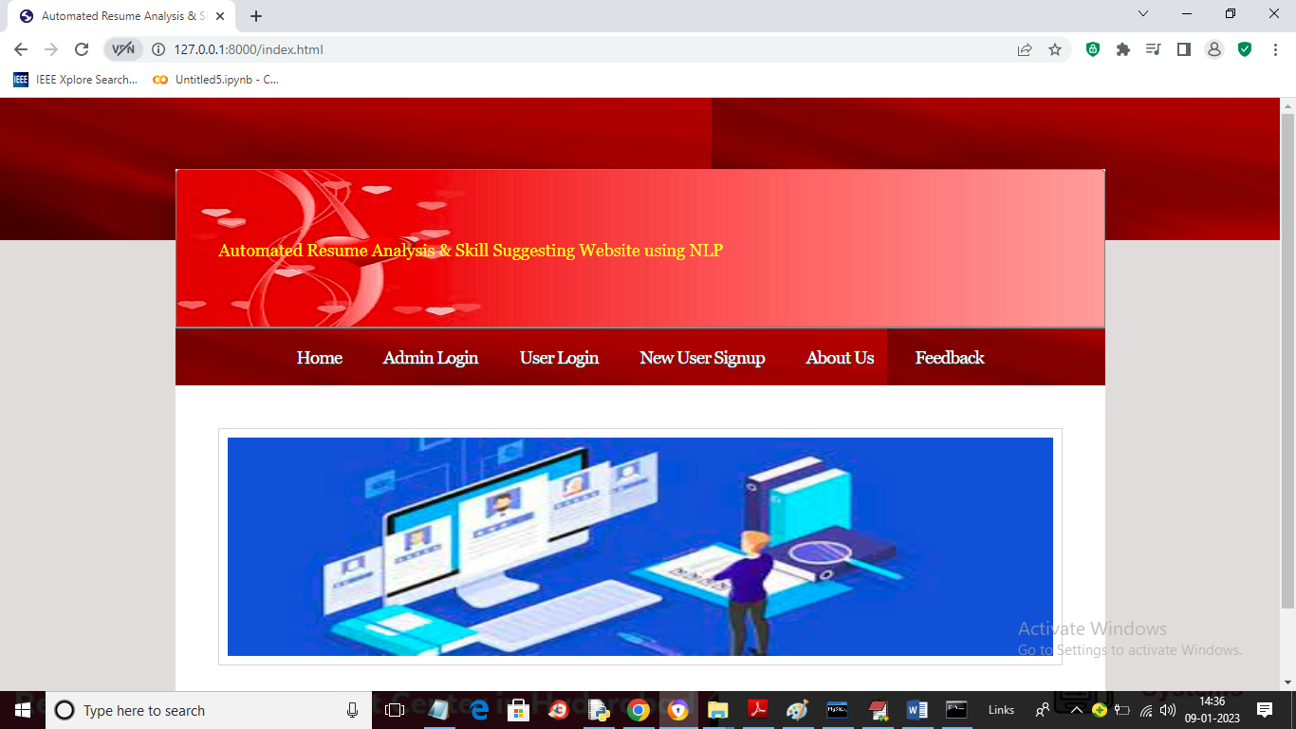

In above screen click on ‘Admin Login’ link to login as admin and then post jobs

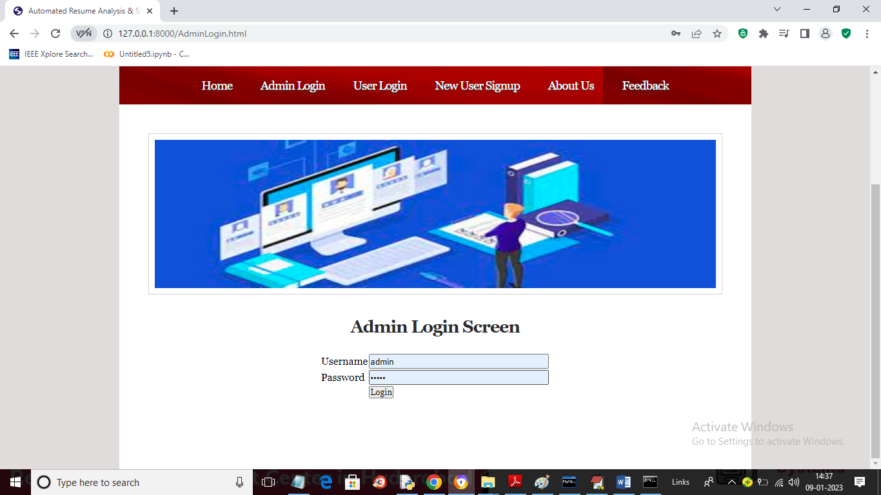

In above screen admin is login and after login will get below page

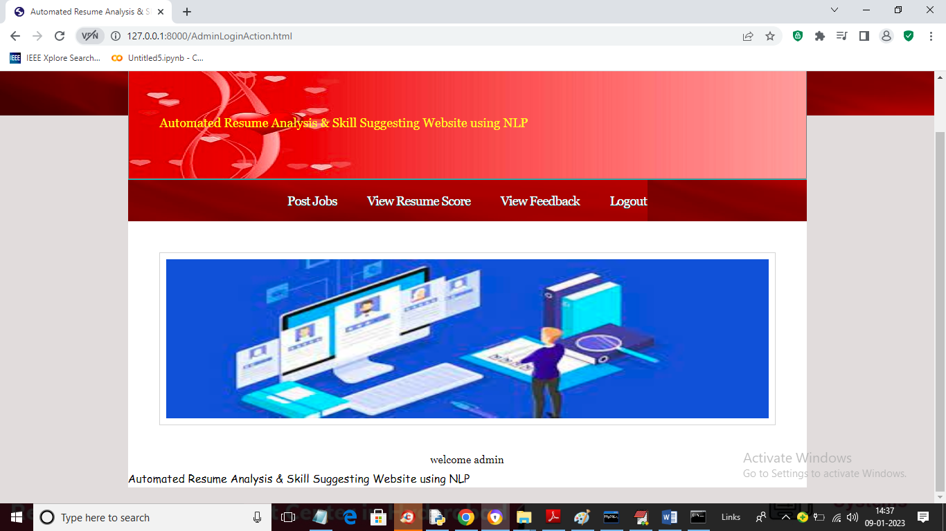

In above screen click on ‘Post Jobs’ link to post jobs

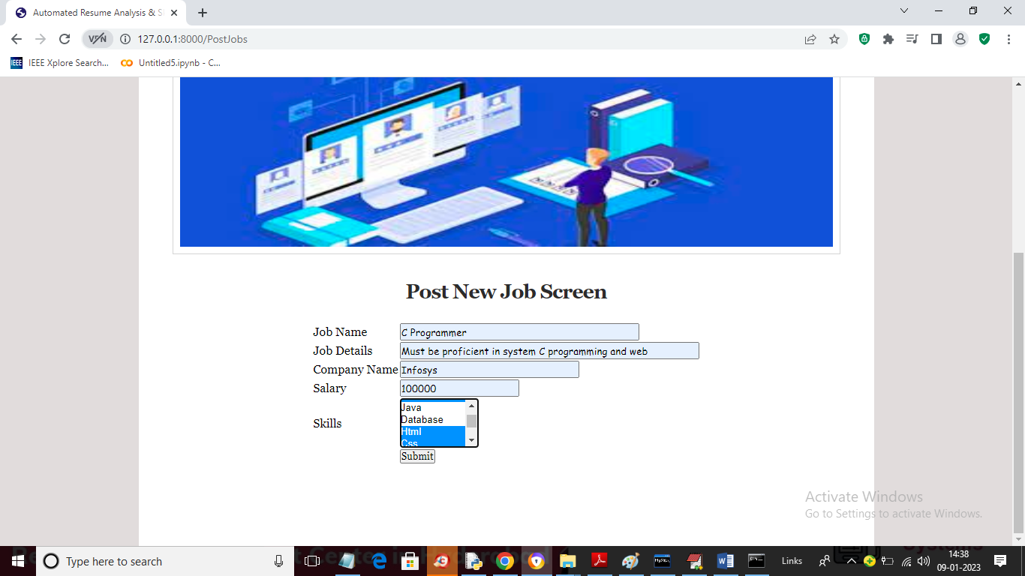

In above screen admin will enter job details and then select require skills and press button to get below output

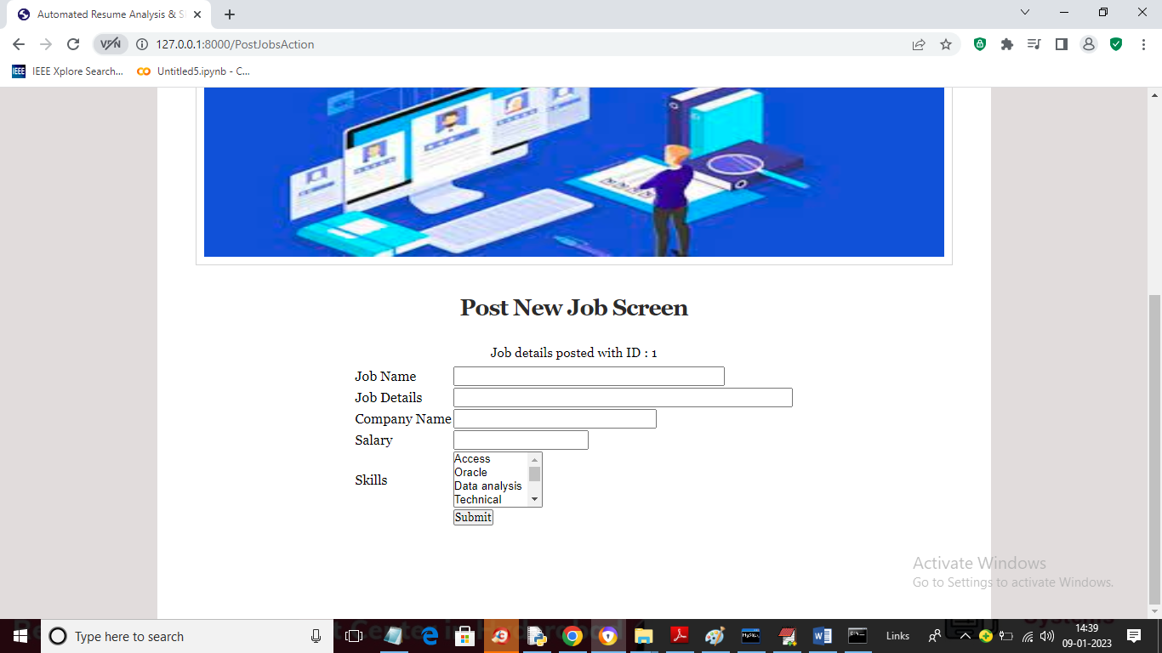

In above screen job details added with JOB ID 1 and now click on ‘View Feedback’ link to get below screen

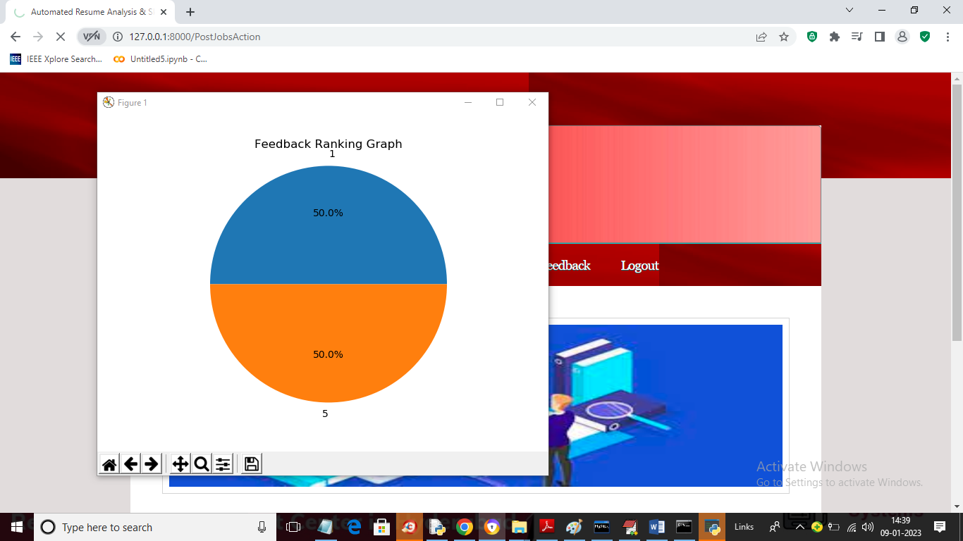

In above screen admin can view Feedback as pie chart and close above graph to get below page

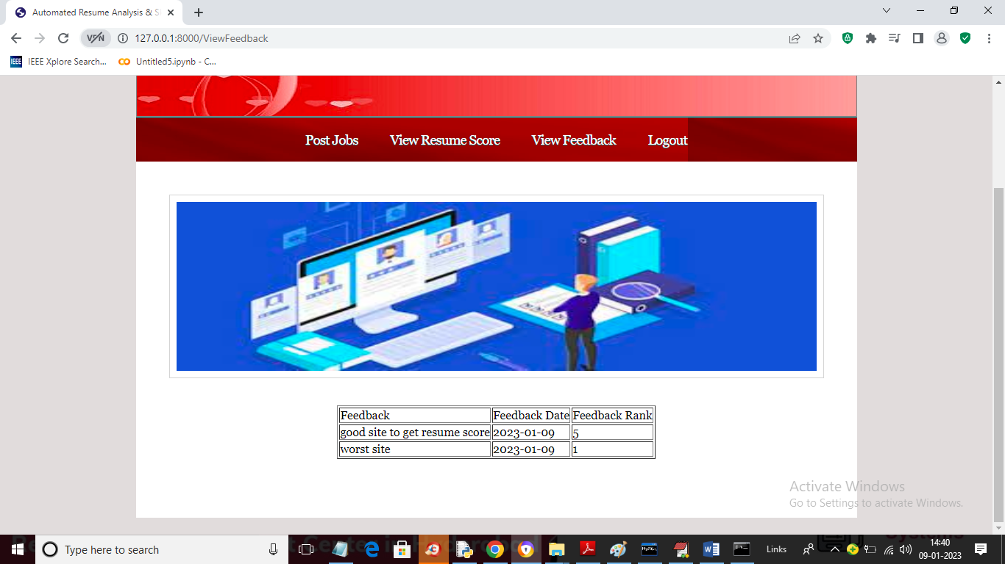

In above screen admin will view all feedbacks and now logout and signup and login new user

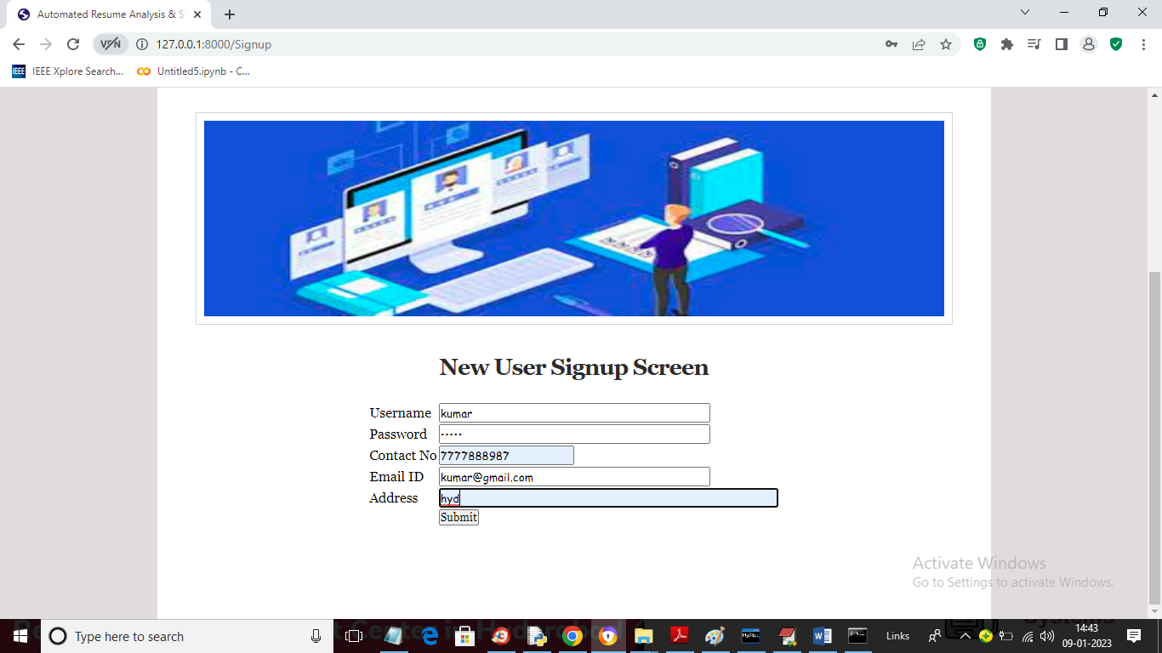

In above screen user is signing up and then press button to get below page

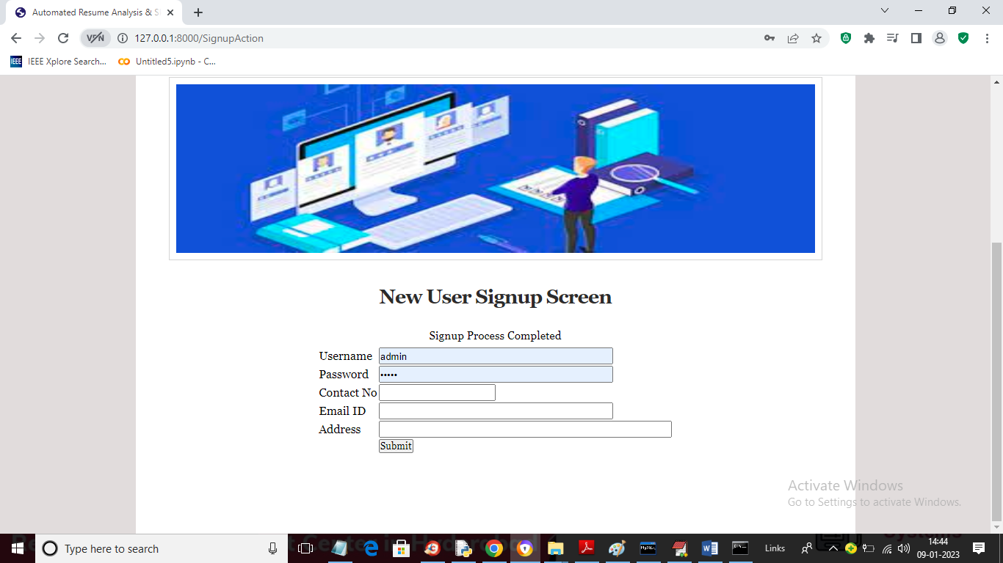

In above screen signup process completed and now click on ‘User Login’ link to get below login page

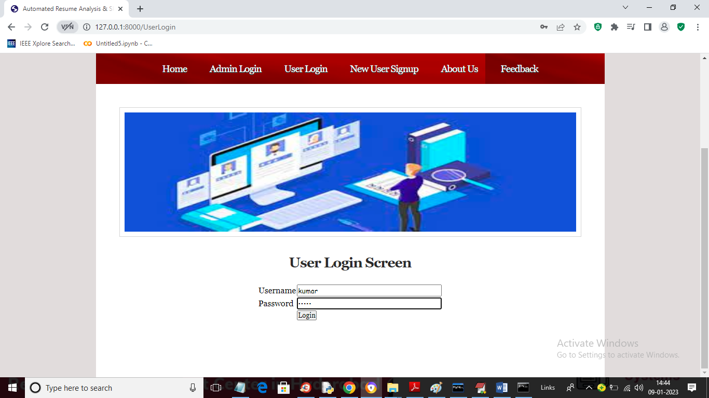

In above screen user is login and after login will get below page

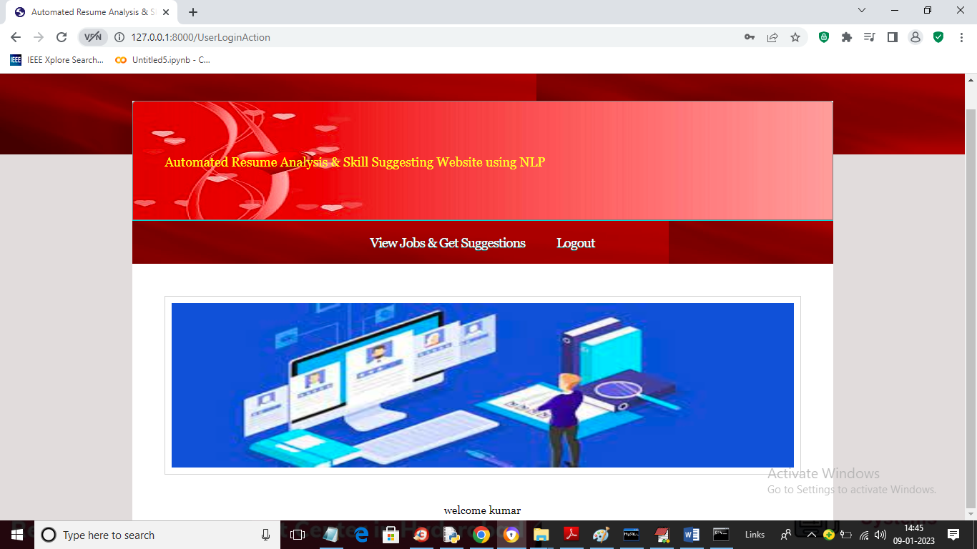

In above screen click on ‘View Jobs & Get Suggestions’ link to view all jobs and suggestion

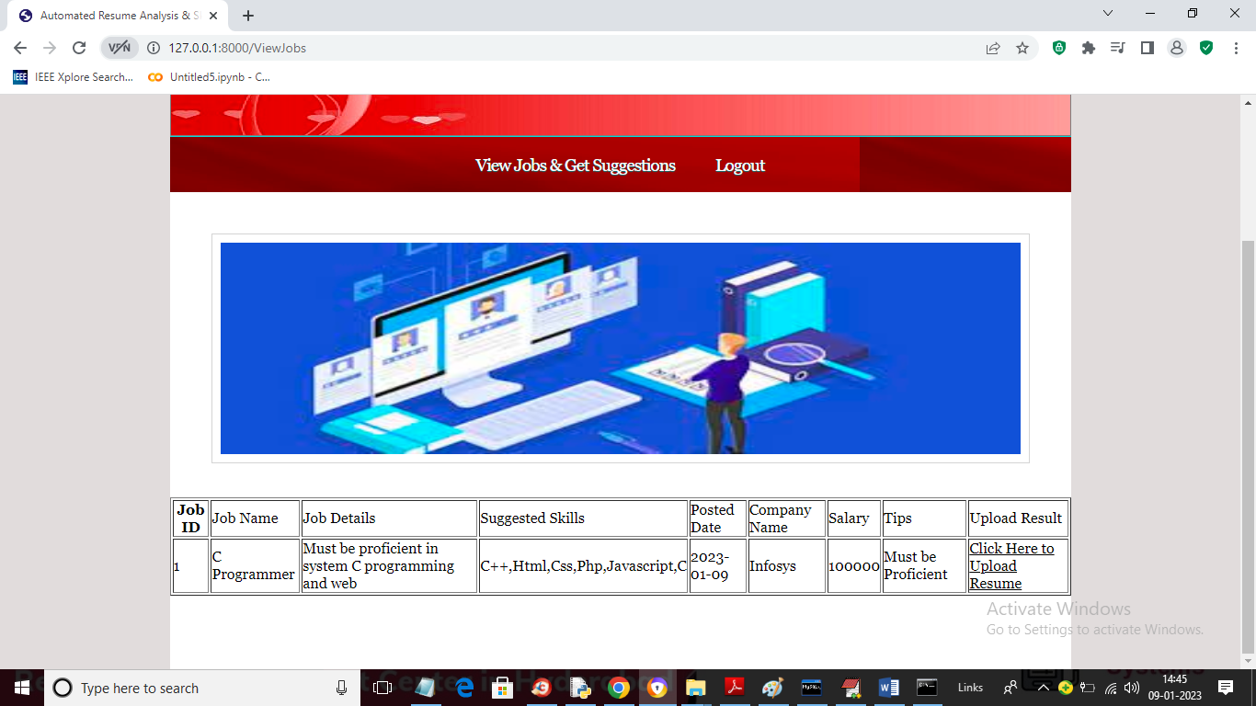

In above screen user can view available jobs and suggested skills and if job is suitable for user then he can click on ‘Click Here to Upload Resume’ link to upload resume and get score

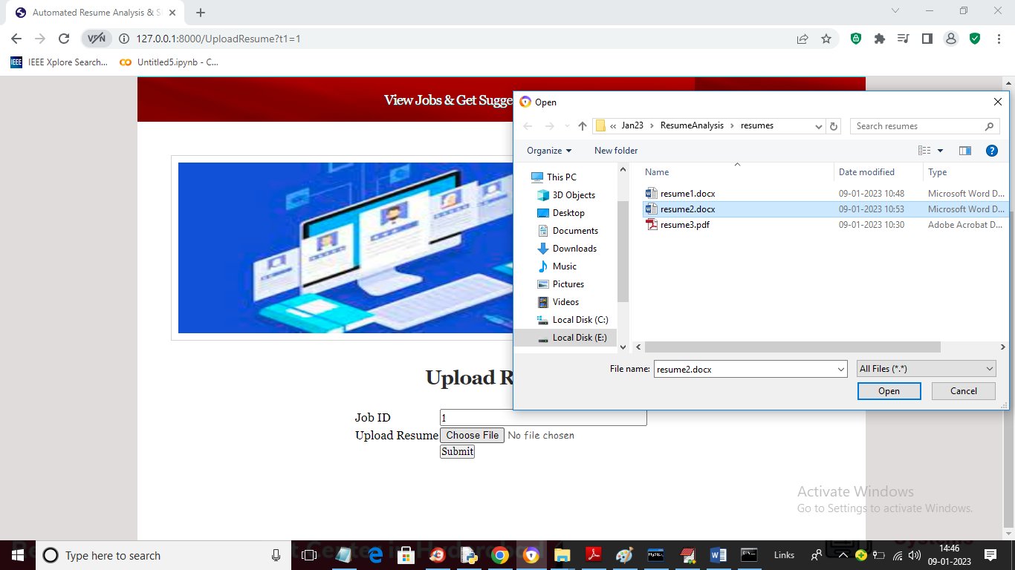

In above screen user is selecting and uploading resume and press ‘Open’ and ‘Submit’ button to get below score value

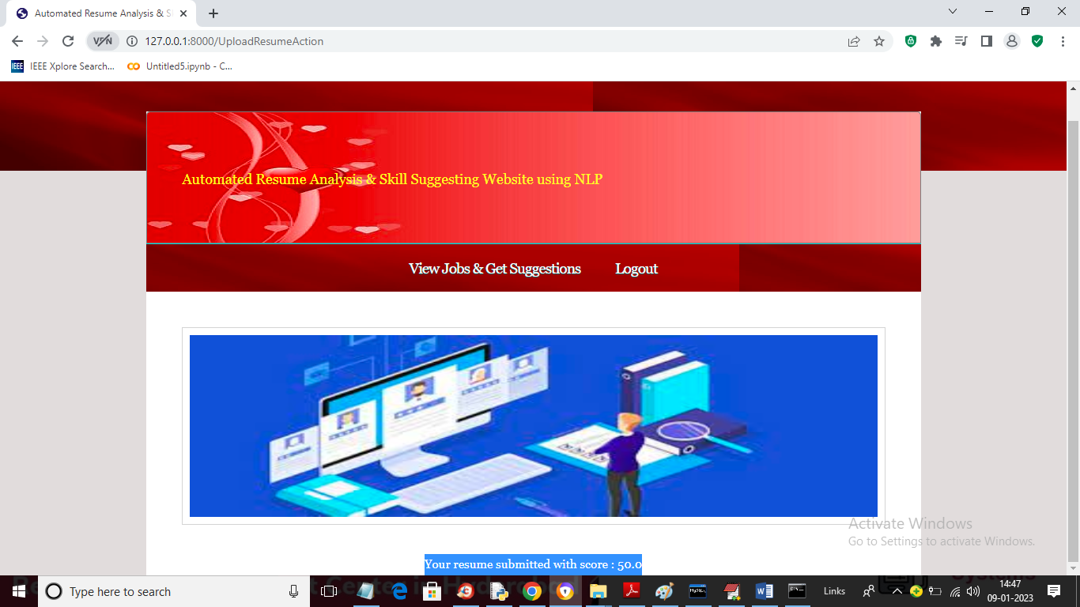

In above screen in blue colour text we can see user resume got 50% score and now login as admin to view all resume details

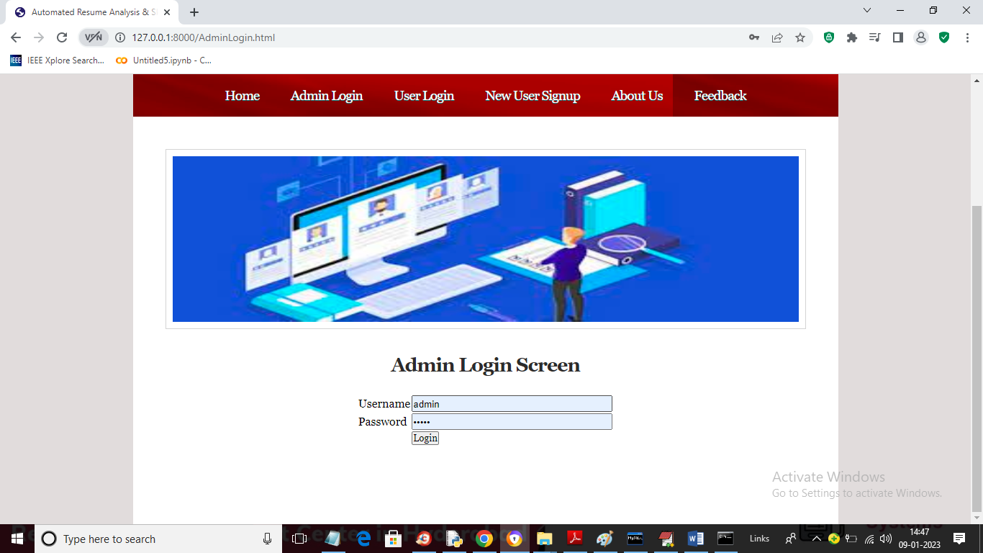

In above screen admin is login to get below page

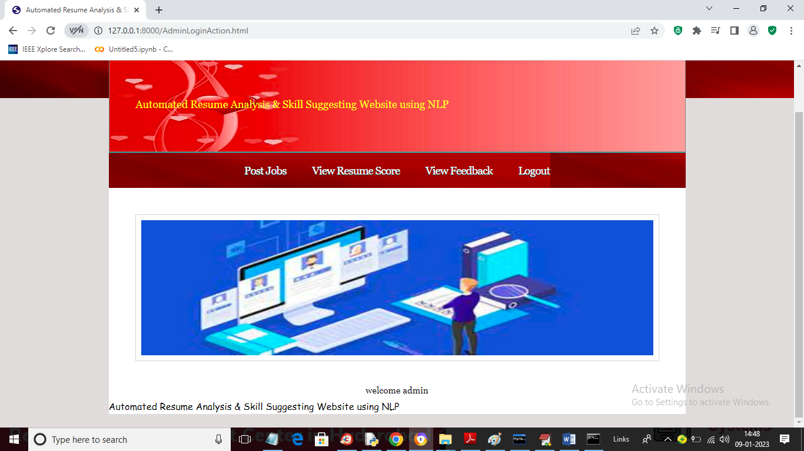

In above screen admin can click on ‘View Resume Score’ to view all applicant resumes with score

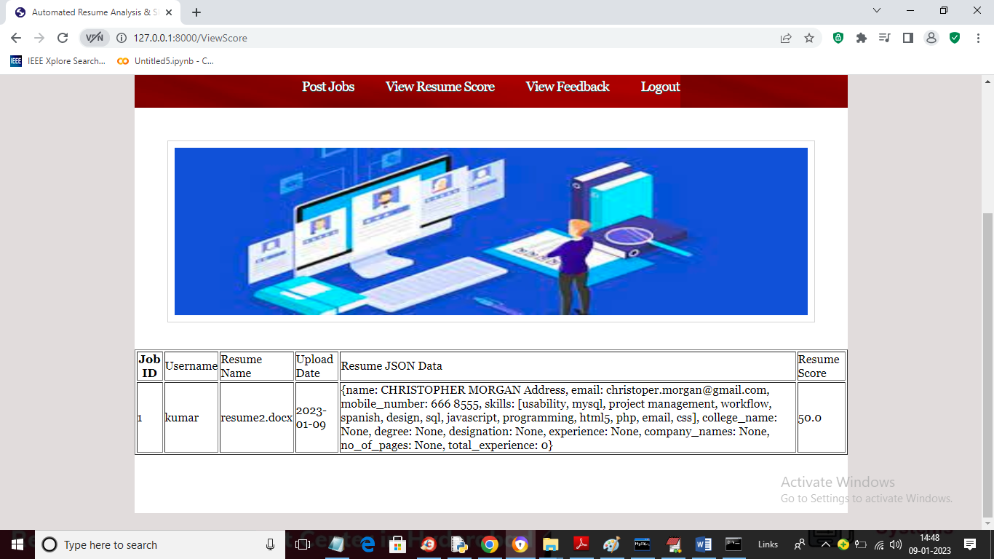

In above screen admin can view resume file name which he can read from server and he can view all resume extracted details in JSON format and in last column he can see the score values

Similarly you can upload and extract details and score from resume and supported formats are only PDF and DOCX files